1. Install Node JS <https://nodejs.org/en/download/>

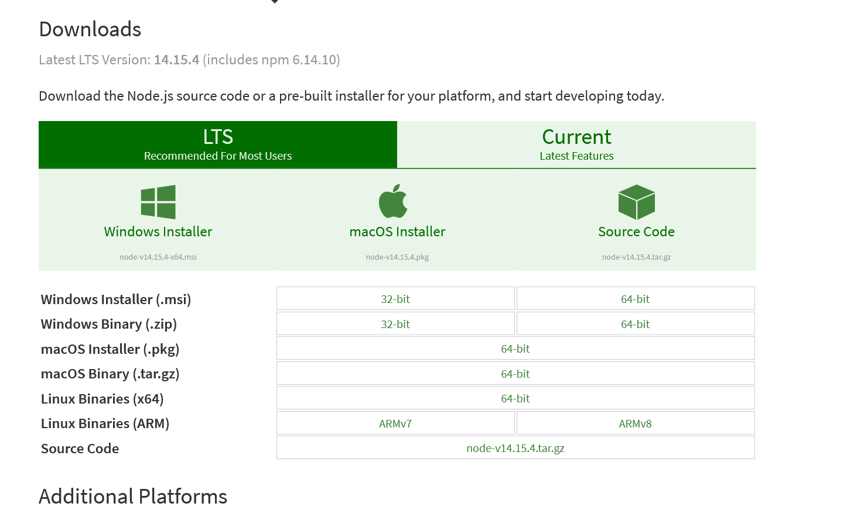

1. Install in local machine and make sure is run. In this case we use windows, co open CMD or Command line and type  ***node –v*** and ***npm –v***

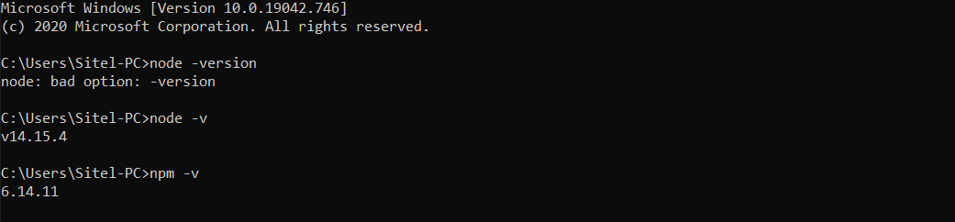

1. There are 2 ways to install *create-vuepress-sites* using ***npx (https://www.npmjs.com/package/npx)*** (library of node js) and other is ***yarn(https://yarnpkg.com/).*** I will follow the npx installation .

### Run generator In the desired folder, run the following command to start the VuePress site generator:

npx create-vuepress-site

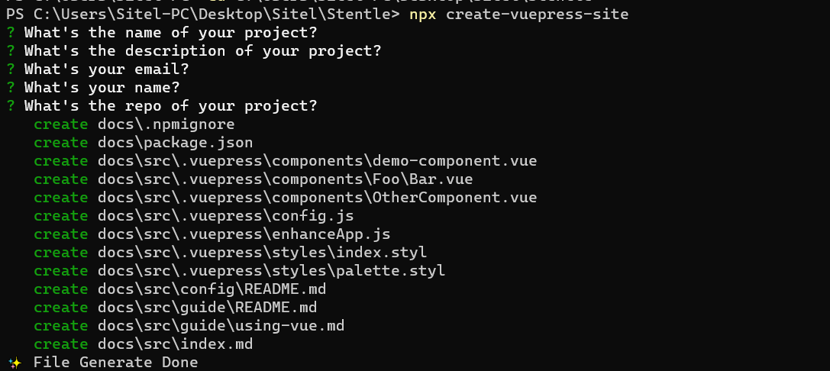

This will create a scaffolded documentation site in the docs directory that is enclosed from the rest of the folder.

* Setup local environment

# Navigate into docs directory where have created project

cd docs

# Install dependencies

npm install

# Start local dev server

npm run dev

By default, you should now see your scaffolded VuePress docs site at <https://localhost:8080>!

